**INT102 Lab 13 Responsive Web Design**

1. Unzip the lab13.zip and open the folder in VS code.
2. Open bakery.html in a browser with a Responsive View so you can expand the viewport window and watch the changing pixel dimensions.

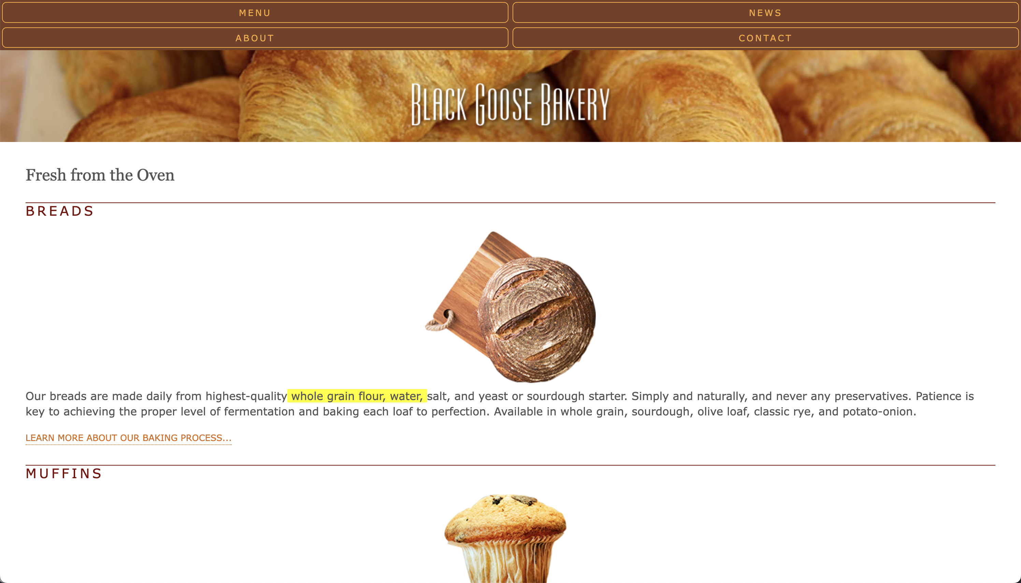

Click “inspect” and click “Toggle device toolbar”

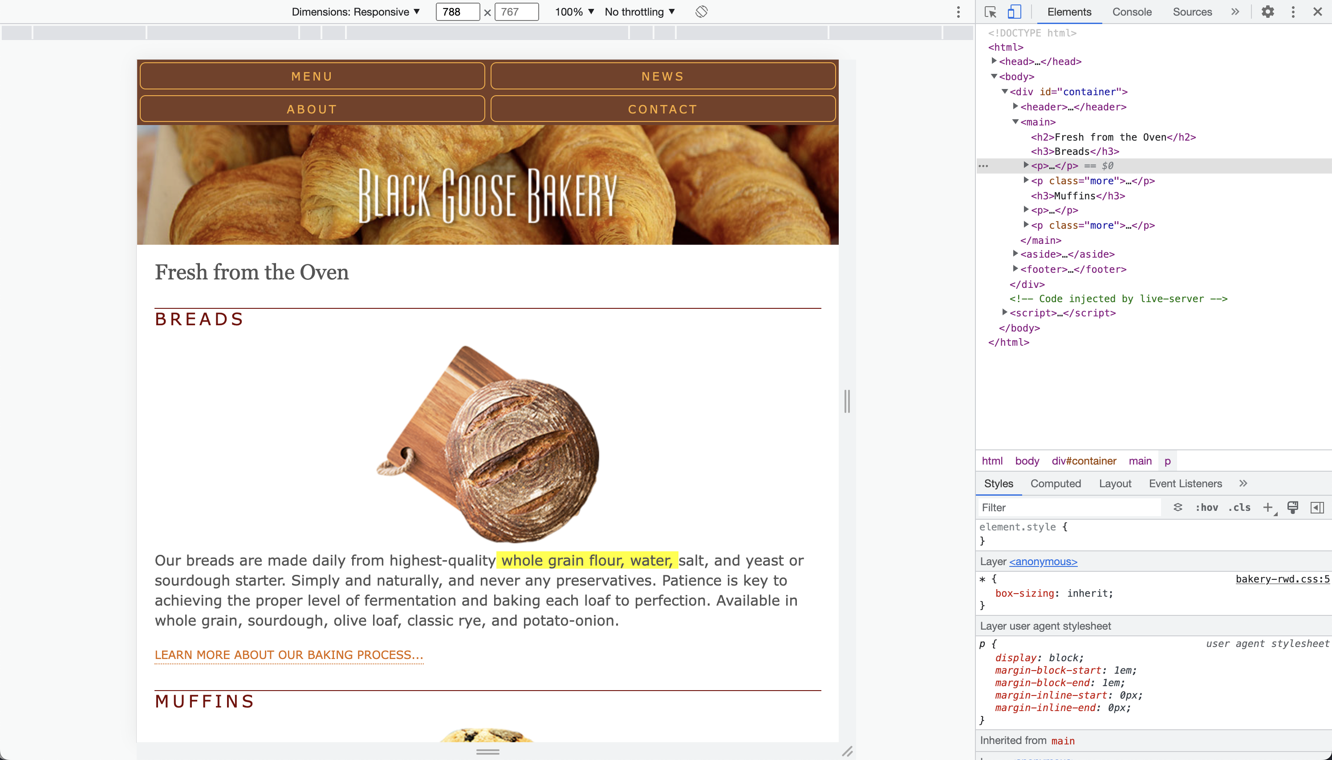

Click “Mobile S – 320px”. The small-screen design is the starting point.

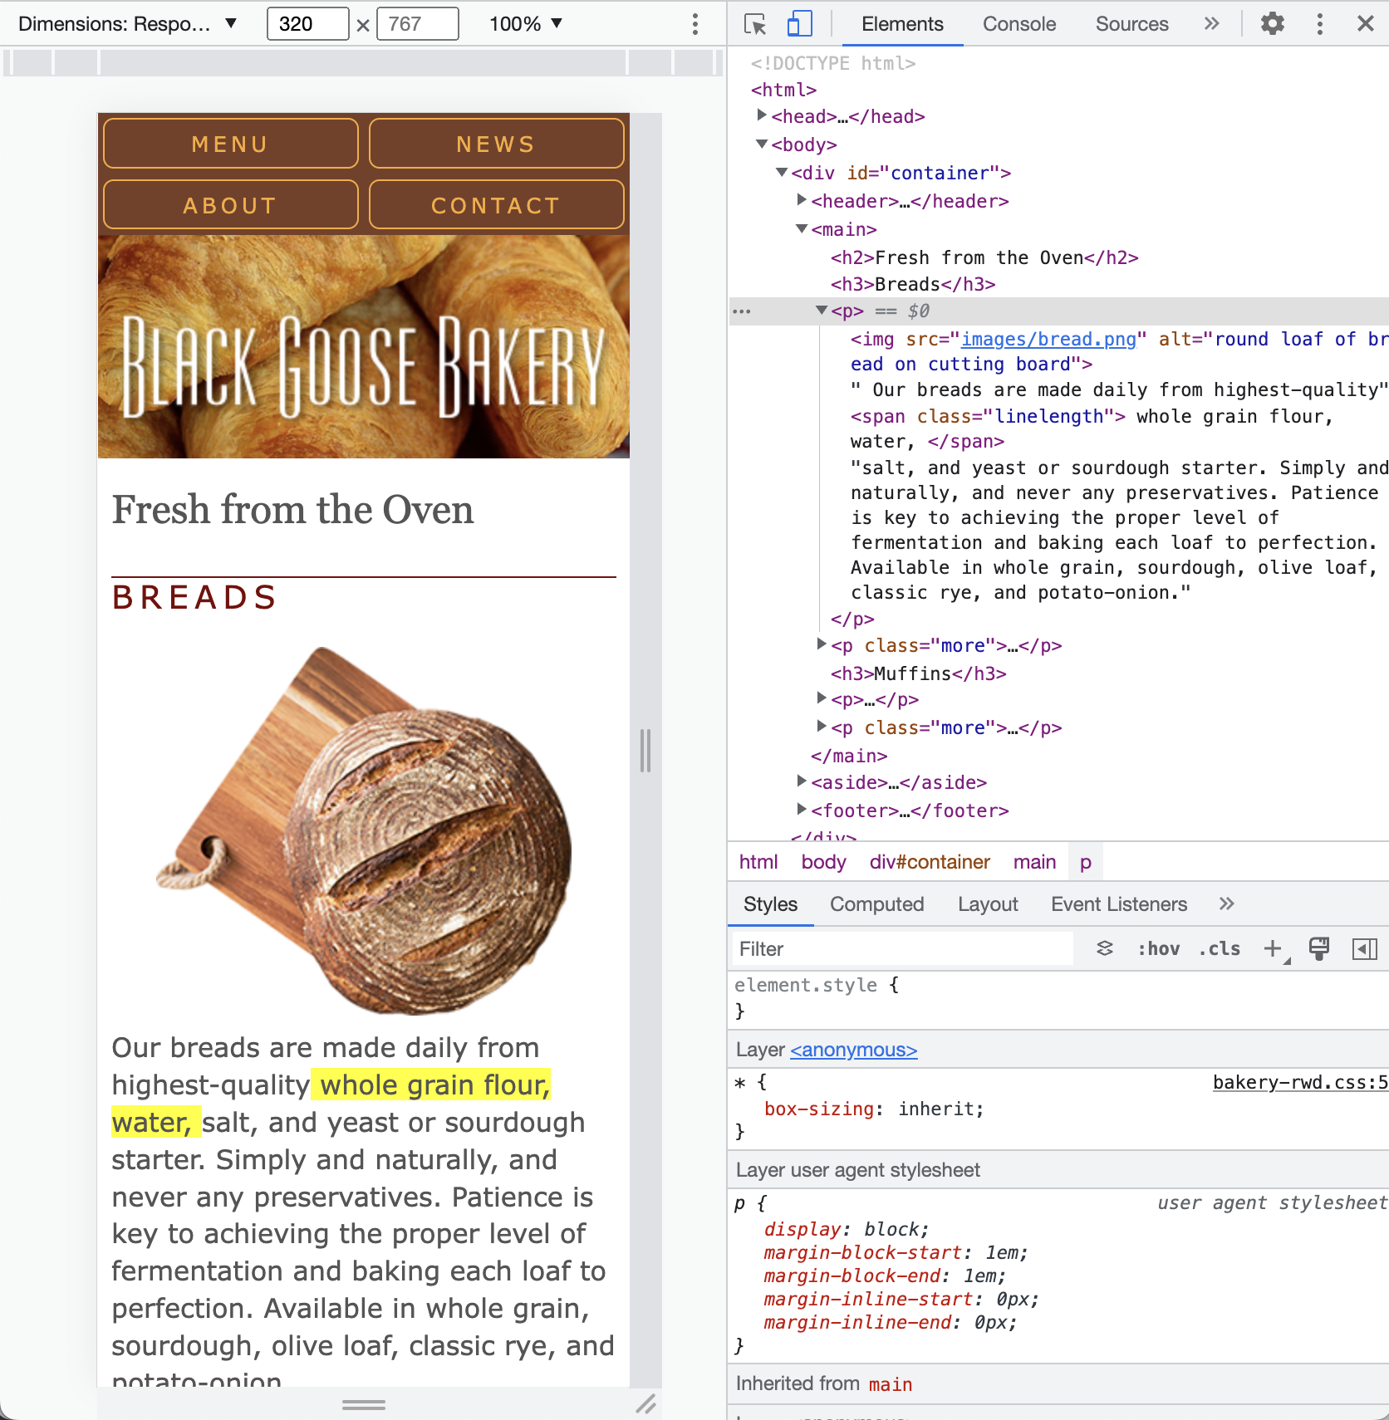 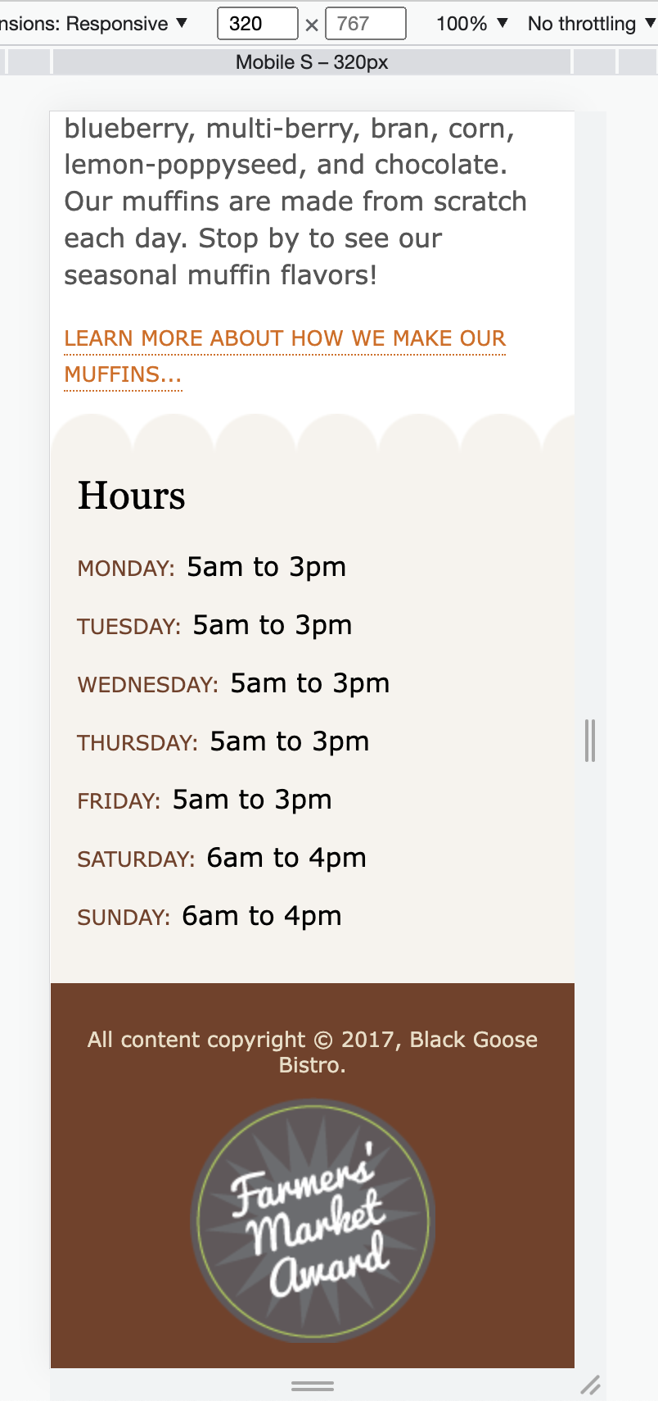

The content of the page is designed to make the initial layout suitable for small screens. The characteristics of this baseline design are following:

* **Layout**

The page has one-column layout for small screens. There are no borders around the main text area, and the Hours section has a scalloped edge on the top instead of the size. That maintains the look and feel, but is more appropriate when the sections are stacked.

* **Navigation**

The navigation menu, which was created with Flexbox, couldn’t flex small enough to fit across a small screen. To make it fit, set the “flex-wrap” to “wrap” (flex-wrap: wrap;) and set the width of each to “50%” so there would be two on each row and make they can both grow and shrink as needed (flex: 1 1 50%).

* **Conditional header text**

The tagline was taking up a lot of vertical space. Because it wasn’t important. Thus, set the paragraph to hide (display: none;) and make it visible again when there is more room.

* **Typography**

On small screens, use a legible sans serif font for the text and not to use web font because it is likely to be difficult to read at small sizes.

* **Images**

Set the img elements for the bread and muffin images to display: block so they have the full width of the viewport to themselves with no text sneaking in next to them. Setting the side margins to auto (margin: .5em auto;) keeps them centered horizontally.

* **Miscellaneous**
  + The award appears at the bottom of the page because there is no enough space for it to be positioned at the top.
  + The span is highlighted from the 45th to 75th characters to reveal when the line lengths get too long.

**Fixing the Navigation**

Now we can start tailoring the design for other screen size. Try to make it wider and you’ll see that some things look OK, and somethings start looking awkward quickly.

When the viewport width is greater than 400px, the navigation should switch to one centered line as soon as there is room.

1. Open the style sheet (bakery-rwd.css). Remember that media queries need to come after other rules for the same declaration, so you should add them at the end of the style sheet file (bakery-rwd.css).

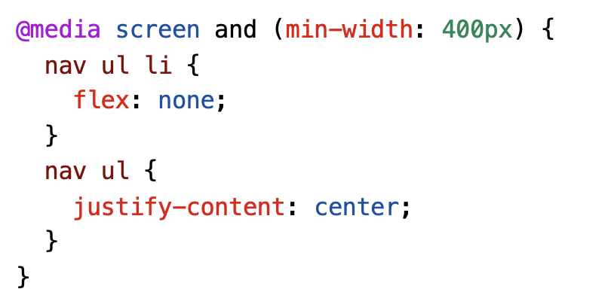

This tells the browser that when the page is on a screen and the viewport is 400 pixels or wider, set the “flex” of menu list items to “none.” The none keyword is equivalent to flex: 0 0 auto ; , so the items are not allowed to grow or shrink and will be sized based on their content and set the flexbox container to center (justify-content: center).

1. Save the style sheet and reload the page in the browser. Try resizing the viewport to see how it works at wider sizes.

Before breakpoint change After

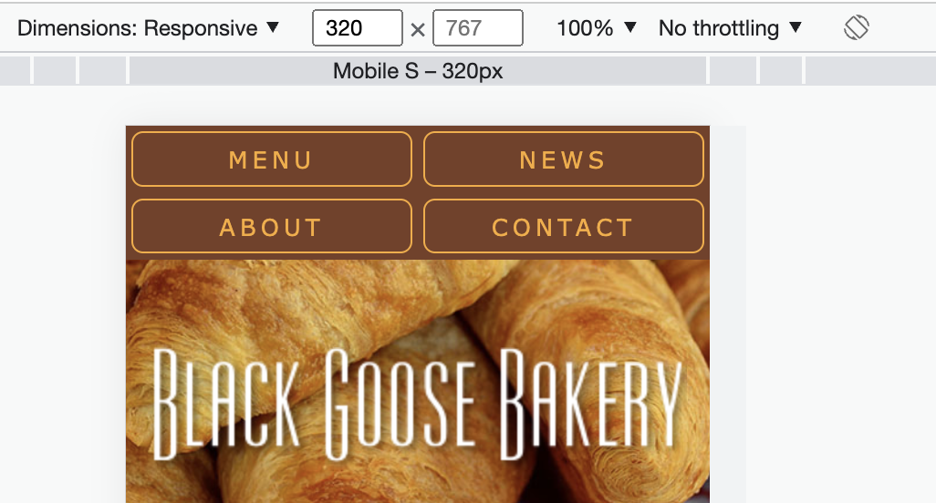 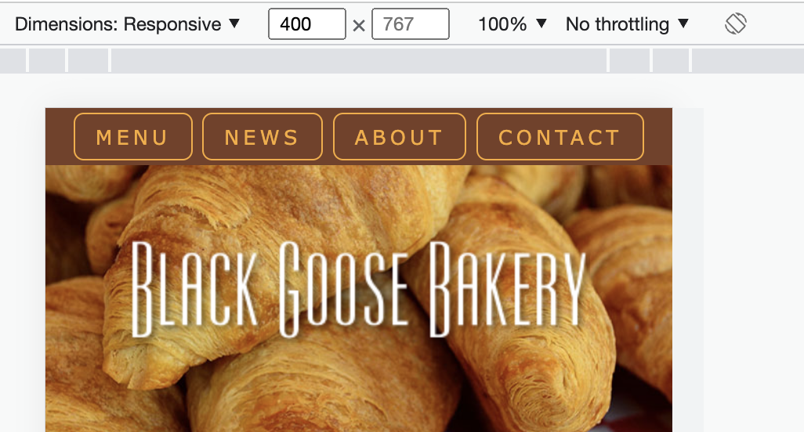

This centered navigation will work for even the widest of screen, so the navigation is all set.

**Floating Images**

As you continue to make the viewport gradually wider, the mains start looking very lonely on a line alone, and that there is room to start wrapping text around them again at about 480 pixels wide.

1. Thus, let float the images to the left once the screen reaches 480 pixels.

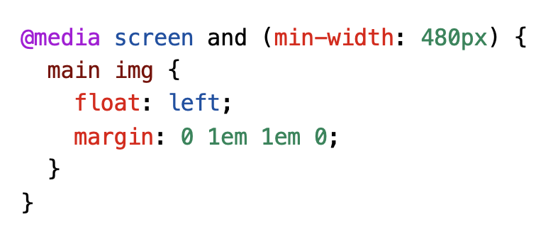

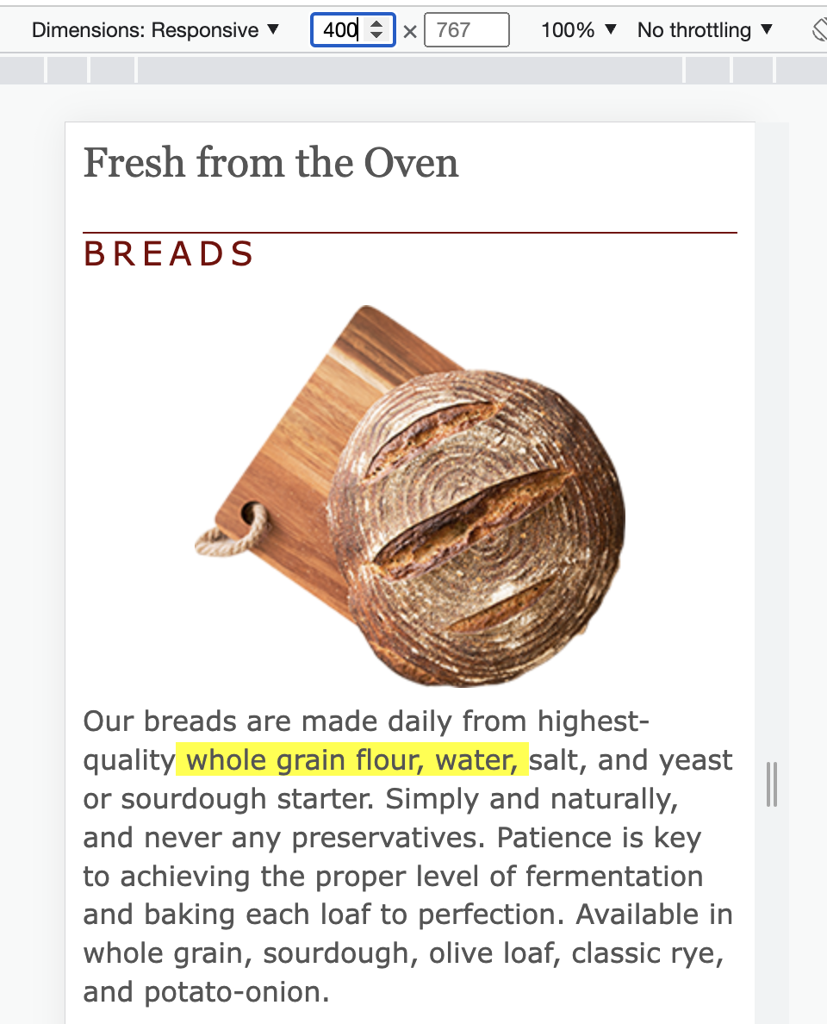 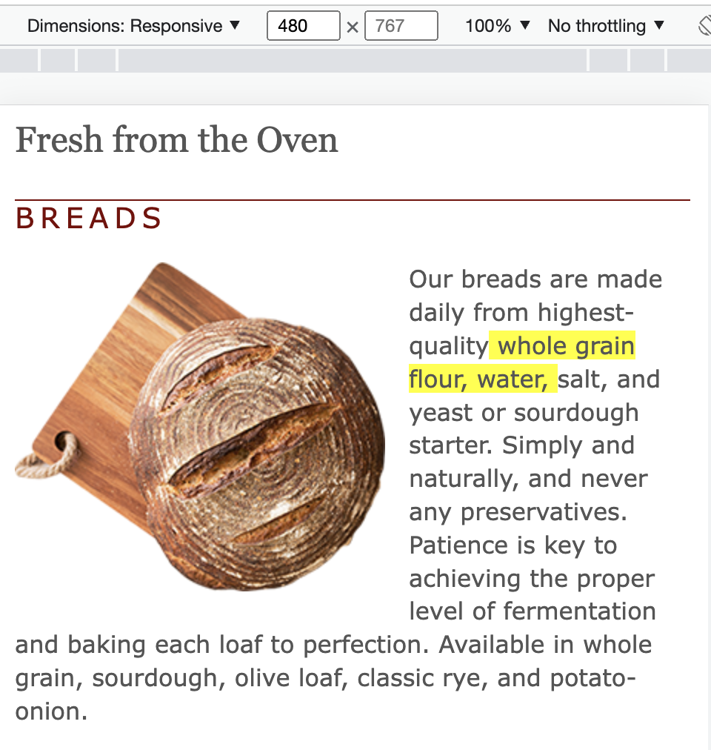

1. Save the style sheet and reload the page in the browser. Try resizing the viewport to see how it works at wider sizes.

**Text and Typography**

1. Once the screen gets to be about 600 pixels wide, there is room for the tagline in the header, so set that to display again (header p { display: none }) . According to the extra space, this also add a rounded border around the main text area to bring it close to the original brand identify for the site. The result is an enhanced one-column layout that is well suited for table-sized devices.

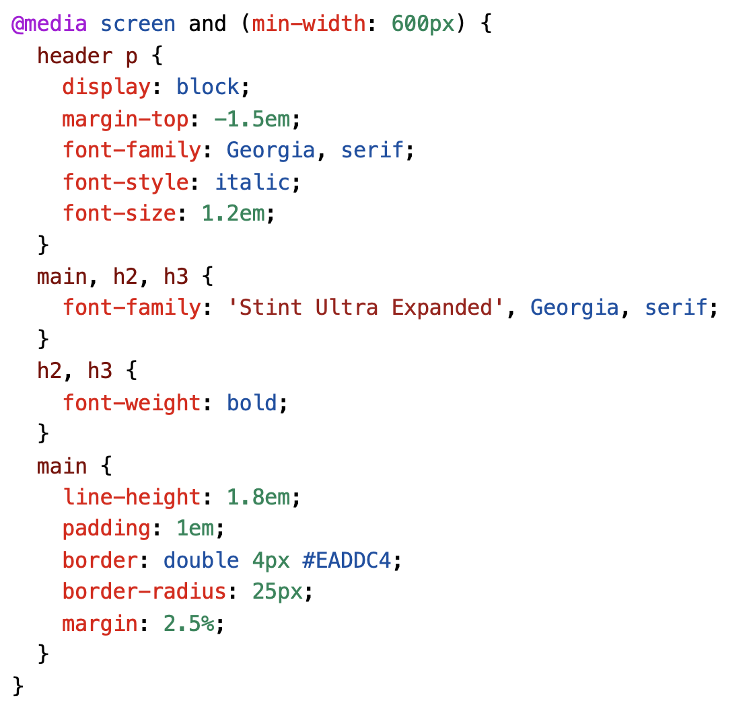

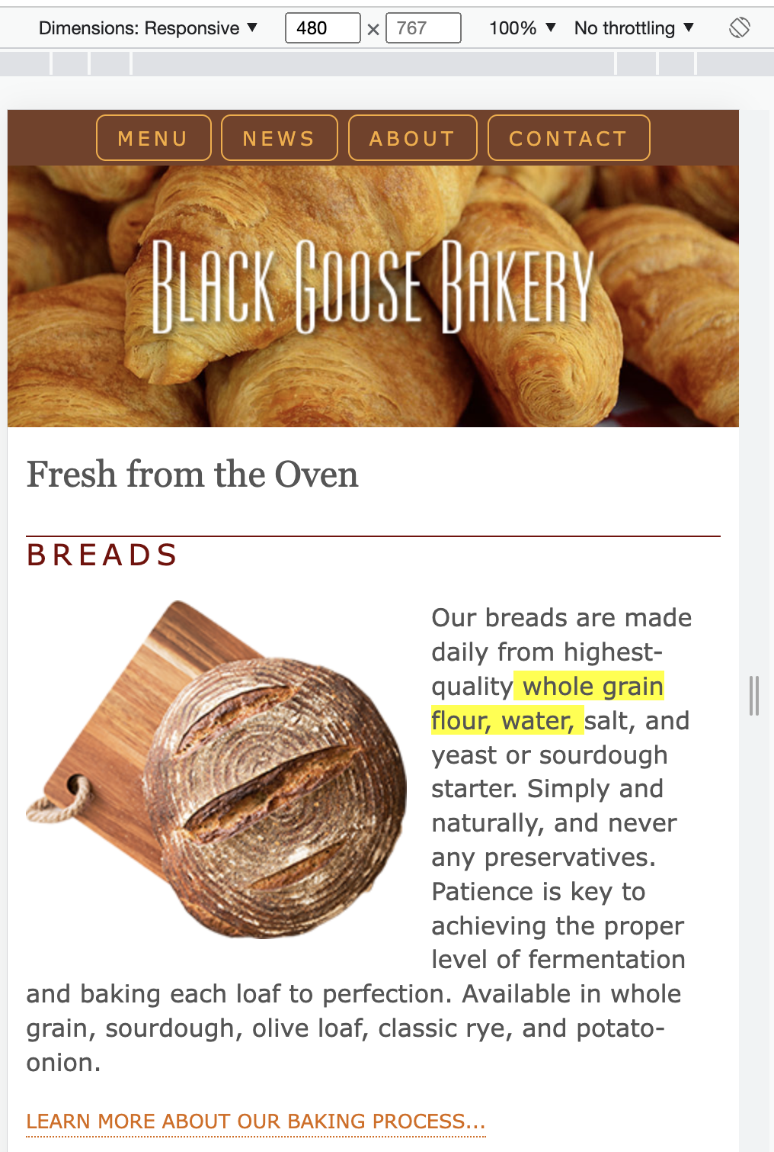 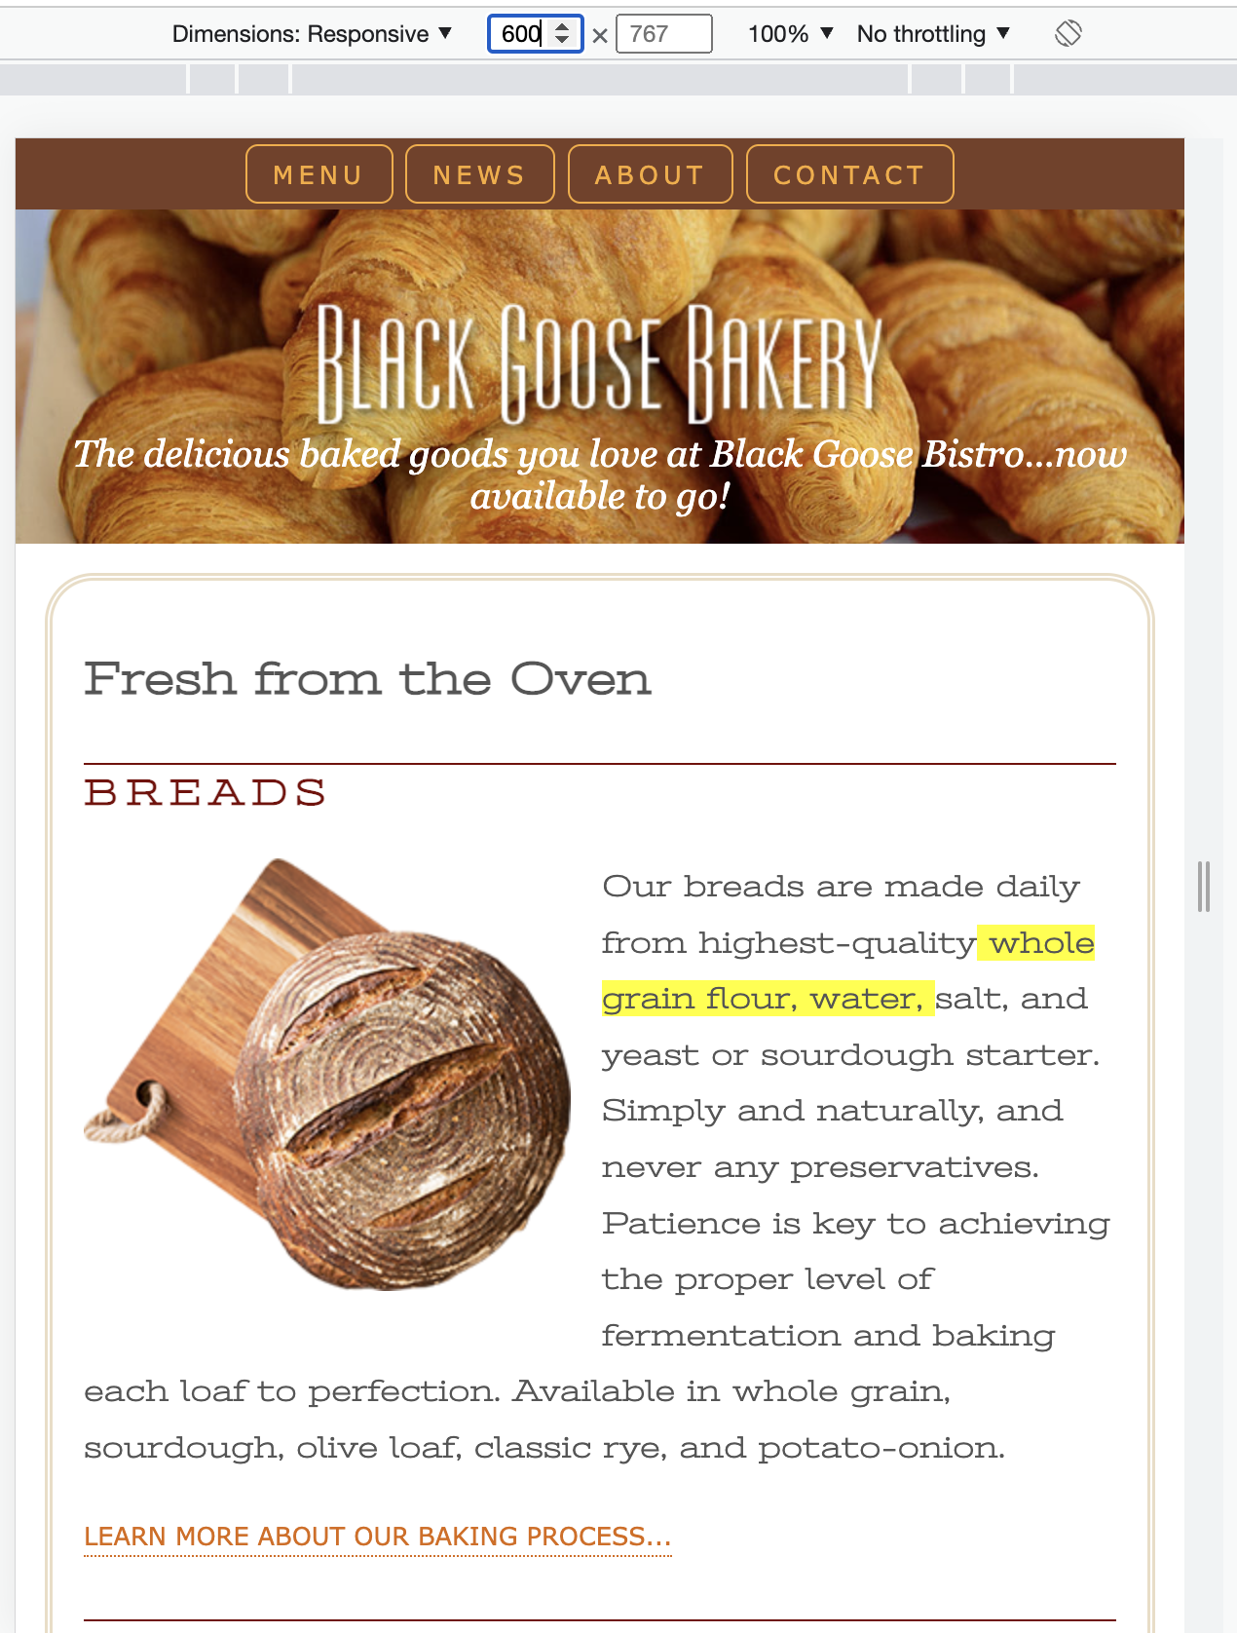

**Multicolumn Layout**

When the viewport continues to wider, the text line is growing longer than 75 characters. We could increase the font size or the margins, but this is a good point to introduce a second column to the layout. We’ve chosen 940 pixels as the point above which the page gets a columned layout.

We will use the grid layout styles for multicolumn layout here. On the aside element, we moved the scalloped background graphic to the left edge. In addition, we set a maximum width of 1200px on the container and set its side margins to auto, so if the browser window is wider than 1,200 pixels, the layout will stay a fixed width and get centered in the viewport.

Finally, we absolutely positioned the award graphic at the top of the page now that there’s enough room.

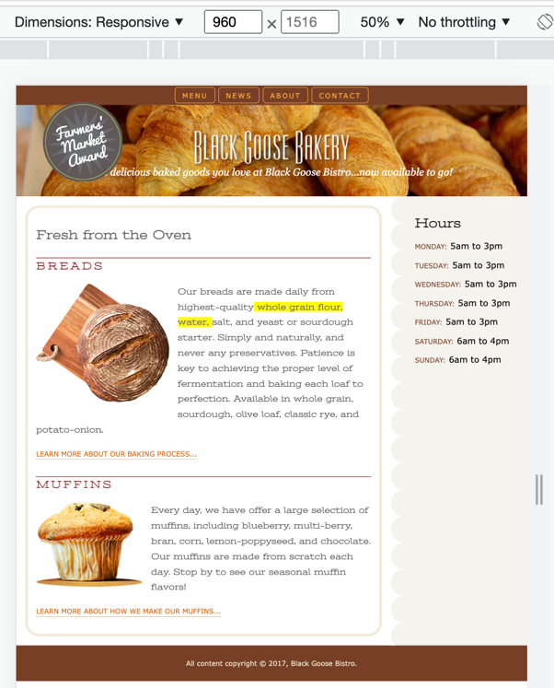 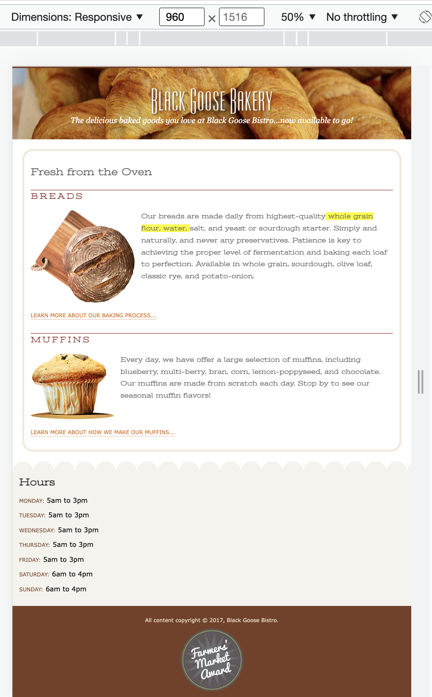

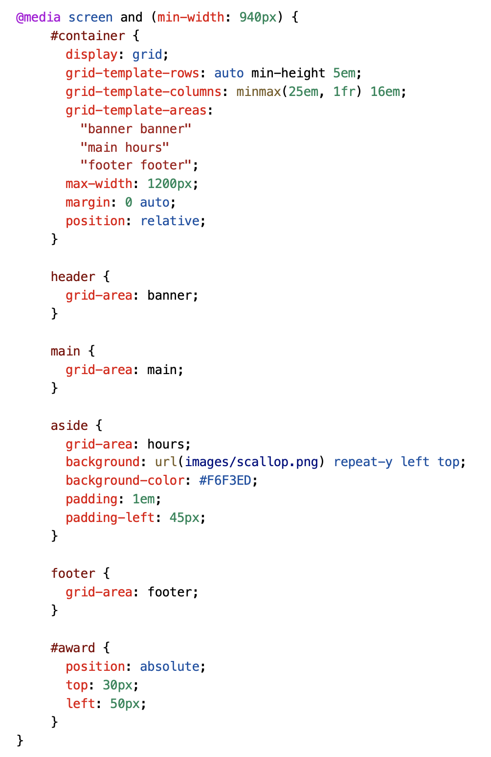

1. Save the style sheet and reload the page in the browser. Try resizing the viewport to see how it works at wider sizes.
2. When you finish, rename the bakery-rwd.css to xxxxxxxxxxx.css (xxxxxxxxxxx is your student id) and upload the xxxxxxxxxxx.css to LEB2.